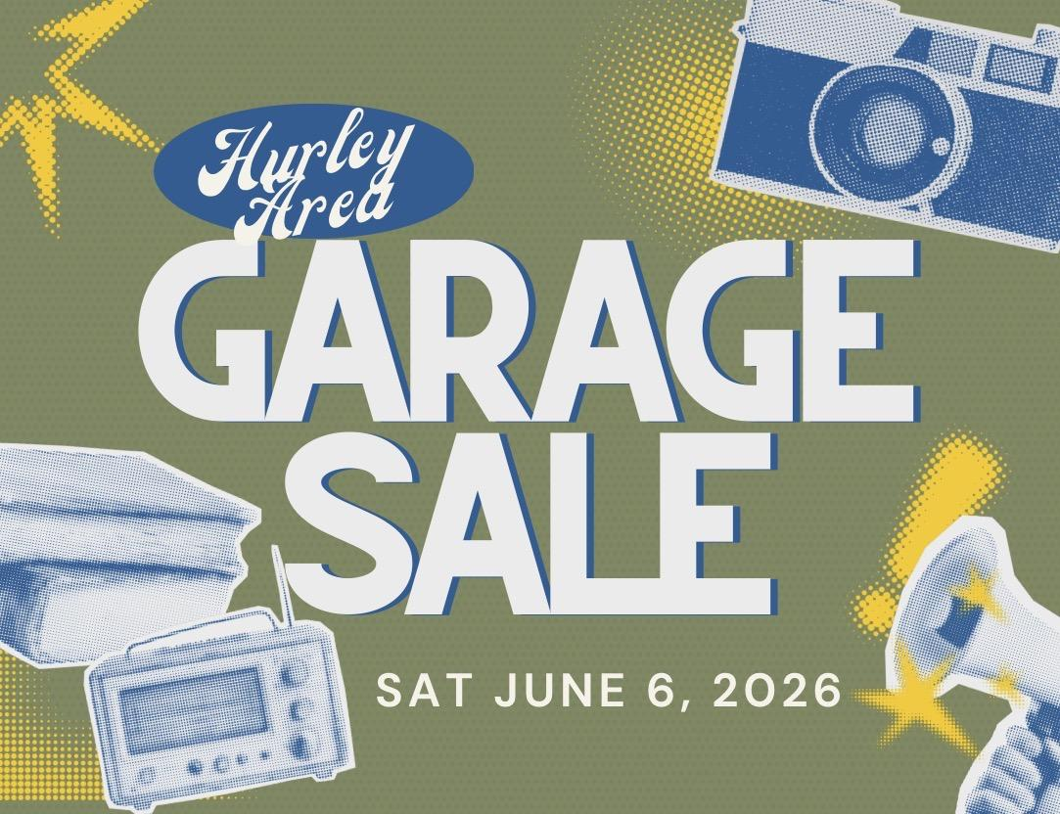

Hurley Area Garage Sale Registration Form

Event Date: Saturday, June 6, 2026

Please complete the form below to register your garage sale location.

Full Name: ________________________________________________________________

Address of Sale Location: ____________________________________________________

Nearest Intersection: _______________________________________________________

Time of Sale (Start – End): ___________________________________________________

Optional Details (if you want to include)_________________________________________

Brief Description of Items for Sale: _____________________________________________

_________________________________________________________________________

_________________________________________________________________________

_________________________________________________________________________

_________________________________________________________________________

Agreement

I understand that this registration is for inclusion in the community garage sale listing and map.

Signature: ___________________________ Date: _______________

